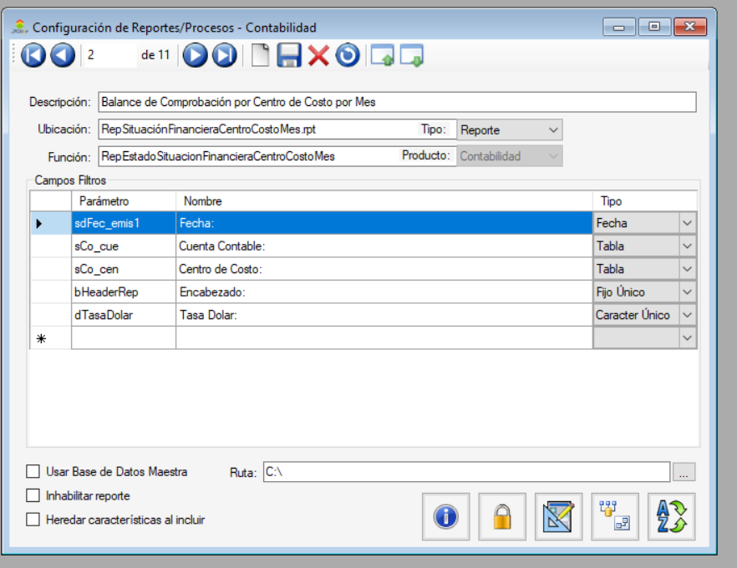

Nombre: Balance de Comprobación por Centro de Costo por Mes

Reporte: RepSituaciónFinancieraCentroCostoMes.rpt

SP: RepEstadoSituacionFinancieraCentroCostoMes

Codigo SP:

USE [C_GLOBAL]

GO

/****** Object: StoredProcedure [dbo].[RepEstadoSituacionFinancieraCentroCostoMes] Script Date: 10/10/2022 3:44:59 p. m. ******/

SET ANSI_NULLS ON

GO

SET QUOTED_IDENTIFIER ON

GO

-- =============================================

-- Author: <Luis Romero>

-- Create date: <11/05/2022>

-- Description: <Reporte Adicional para visualizar el Estado Situación Financiera por Centro de Costo y Mes>

-- =============================================

ALTER PROCEDURE [dbo].[RepEstadoSituacionFinancieraCentroCostoMes]

-- Add the parameters for the stored procedure here

@sCo_cue_d char(20) = null,

@sCo_cue_h char(20) = null,

@sdFec_emis1_d smalldatetime = null,

@sdFec_emis1_h smalldatetime = null,

@sCo_cen_d char(20) = null, -- auxiliares en los renglones

@sCo_cen_h char(20) = null,

@sCampOrderBy varchar(16) = null,

@sDir varchar(6) = null,

@bHeaderRep bit = 0,

@dTasaDolar decimal(18,5) = 1 --tasa dolares conversion

AS

BEGIN

-- SET NOCOUNT ON added to prevent extra result sets from

-- interfering with SELECT statements.

SET NOCOUNT ON;

SELECT b.co_cen,

sccentro.des_cen,

b.co_cue,

sccuenta.des_cue,

YEAR(b.fec_emis) AS Anio,

(SELECT ISNULL(SUM(a.monto_d)-SUM(a.monto_h),0) FROM scren_co a WHERE a.co_cen = b.co_cen

AND a.co_cue = b.co_cue AND a.mes = 1) AS Enero,

(SELECT ISNULL(SUM(a.monto_d)-SUM(a.monto_h),0) FROM scren_co a WHERE a.co_cen = b.co_cen

AND a.co_cue = b.co_cue AND a.mes = 2) AS Febrero,

(SELECT ISNULL(SUM(a.monto_d)-SUM(a.monto_h),0) FROM scren_co a WHERE a.co_cen = b.co_cen

AND a.co_cue = b.co_cue AND a.mes = 3) AS Marzo,

(SELECT ISNULL(SUM(a.monto_d)-SUM(a.monto_h),0) FROM scren_co a WHERE a.co_cen = b.co_cen

AND a.co_cue = b.co_cue AND a.mes = 4) AS Abril,

(SELECT ISNULL(SUM(a.monto_d)-SUM(a.monto_h),0) FROM scren_co a WHERE a.co_cen = b.co_cen

AND a.co_cue = b.co_cue AND a.mes = 5) AS Mayo,

(SELECT ISNULL(SUM(a.monto_d)-SUM(a.monto_h),0) FROM scren_co a WHERE a.co_cen = b.co_cen

AND a.co_cue = b.co_cue AND a.mes = 6) AS Junio,

(SELECT ISNULL(SUM(a.monto_d)-SUM(a.monto_h),0) FROM scren_co a WHERE a.co_cen = b.co_cen

AND a.co_cue = b.co_cue AND a.mes = 7) AS Julio,

(SELECT ISNULL(SUM(a.monto_d)-SUM(a.monto_h),0) FROM scren_co a WHERE a.co_cen = b.co_cen

AND a.co_cue = b.co_cue AND a.mes = 8) AS Agosto,

(SELECT ISNULL(SUM(a.monto_d)-SUM(a.monto_h),0) FROM scren_co a WHERE a.co_cen = b.co_cen

AND a.co_cue = b.co_cue AND a.mes = 9) AS Septiembre,

(SELECT ISNULL(SUM(a.monto_d)-SUM(a.monto_h),0) FROM scren_co a WHERE a.co_cen = b.co_cen

AND a.co_cue = b.co_cue AND a.mes = 10) AS Octubre,

(SELECT ISNULL(SUM(a.monto_d)-SUM(a.monto_h),0) FROM scren_co a WHERE a.co_cen = b.co_cen

AND a.co_cue = b.co_cue AND a.mes = 11) AS Noviembre,

(SELECT ISNULL(SUM(a.monto_d)-SUM(a.monto_h),0) FROM scren_co a WHERE a.co_cen = b.co_cen

AND a.co_cue = b.co_cue AND a.mes = 12) AS Diciembre,

@dTasaDolar AS tasa_dolar

FROM scren_co b INNER JOIN sccentro ON b.co_cen = sccentro.co_cen

INNER JOIN sccuenta ON b.co_cue = sccuenta.co_cue

WHERE

-- FILTRO POR FECHA

((@sdFec_emis1_d is null OR b.fec_emis >= @sdFec_emis1_d) AND (@sdFec_emis1_h is null OR b.fec_emis <= @sdFec_emis1_h))

-- FILTRO POR CENTRO DE COSTO

AND ((@sCo_cen_d is null OR b.co_cen >= @sCo_cen_d) AND

(@sCo_cen_h is null OR (@sCo_cen_h is null AND b.co_cen is null ) OR b.co_cen <= @sCo_cen_h))

-- FILTRO POR CUENTA CONTABLE

AND ((@sCo_cue_d is null OR b.co_cue >= @sCo_cue_d) AND

(@sCo_cue_h is null OR (@sCo_cue_h is null AND b.co_cue is null ) OR b.co_cue <= @sCo_cue_h))

GROUP BY

b.co_cen,

sccentro.des_cen,

b.co_cue,

sccuenta.des_cue,

YEAR(b.fec_emis)

ORDER BY

b.co_cen,

b.co_cue

END

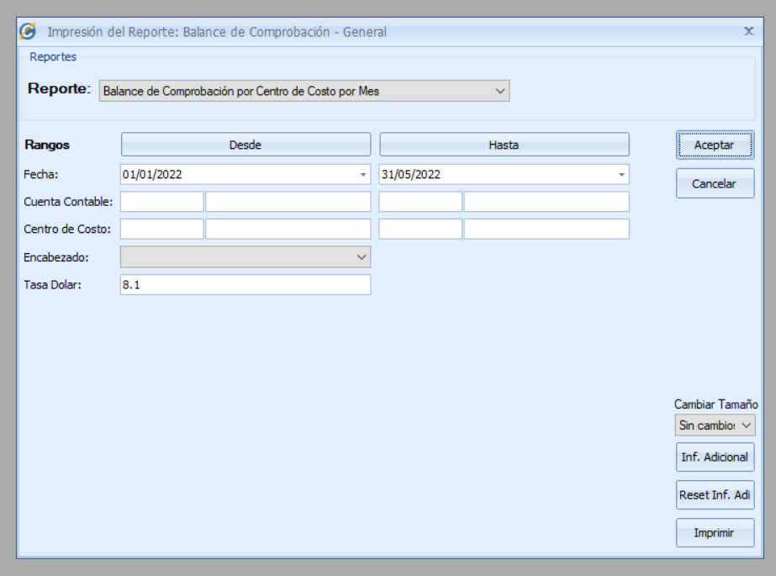

Actualización 12/06/2023

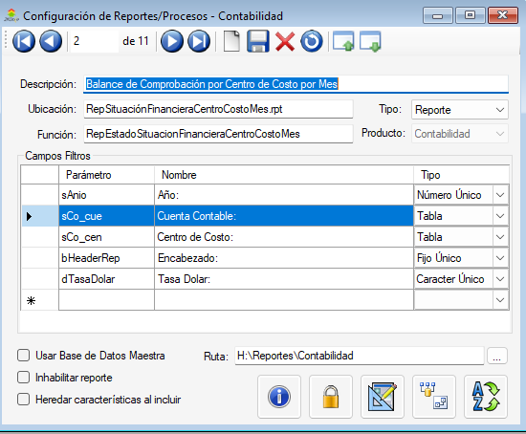

USE [C_PARAM]

GO

/****** Object: StoredProcedure [dbo].[RepEstadoSituacionFinancieraCentroCostoMes] Script Date: 12/6/2023 8:00:47 a. m. ******/

SET ANSI_NULLS ON

GO

SET QUOTED_IDENTIFIER ON

GO

-- =============================================

-- Author: <Luis Romero>

-- Create date: <11/05/2022>

-- Description: <Reporte Adicional para visualizar el Estado Situación Financiera por Centro de Costo y Mes>

-- Modificado: 11/06/2023 ALR

-- Se cambio scritp para que muestre datos por mes en un año, no hacia filtro por fechas

-- =============================================

ALTER PROCEDURE [dbo].[RepEstadoSituacionFinancieraCentroCostoMes]

-- Add the parameters for the stored procedure here

@sCo_cue_d char(20) = null,

@sCo_cue_h char(20) = null,

@sdFec_emis1_d smalldatetime = null,

@sdFec_emis1_h smalldatetime = null,

@sCo_cen_d char(20) = null, -- auxiliares en los renglones

@sCo_cen_h char(20) = null,

@sCampOrderBy varchar(16) = null,

@sDir varchar(6) = null,

@bHeaderRep bit = 0,

@dTasaDolar decimal(18,5) = 1, --tasa dolares conversion

@sAnio int = 0

AS

BEGIN

-- SET NOCOUNT ON added to prevent extra result sets from

-- interfering with SELECT statements.

SET NOCOUNT ON;

SELECT co_cen, des_cen, co_cue, des_cue, Anio,

ISNULL([1],0) AS [Enero], ISNULL([2],0) AS [Febrero], ISNULL([3],0) AS [Marzo], ISNULL([4],0) AS [Abril],

ISNULL([5],0) AS [Mayo], ISNULL([6],0) AS [Junio], ISNULL([7],0) AS [Julio], ISNULL([8],0) AS [Agosto],

ISNULL([9],0) AS [Septiembre], ISNULL([10],0) AS [Octubre], ISNULL([11],0) AS [Noviembre], ISNULL([12],0) AS [Diciembre],

@dTasaDolar AS tasa_dolar

FROM (SELECT a.co_cen ,

sccentro.des_cen,

a.co_cue,

sccuenta.des_cue,

a.mes AS Meses,

a.anho AS Anio,

ISNULL(SUM(a.monto_d)-SUM(a.monto_h),0) AS Monto

FROM scren_co a INNER JOIN sccentro ON a.co_cen = sccentro.co_cen

INNER JOIN sccuenta ON a.co_cue = sccuenta.co_cue

INNER JOIN sccompro ON a.comp_num = sccompro.comp_num

AND a.mes =sccompro.mes

AND a.anho = sccompro.anho

AND sccompro.origen <> 'CIE'

GROUP BY a.co_cen,

sccentro.des_cen,

a.co_cue,

sccuenta.des_cue,

a.mes,

a.anho) AS Despachos

PIVOT (SUM(Monto) FOR Meses IN ([1],[2],[3],[4],[5],[6],[7],[8],[9],[10],[11],[12]) ) AS pvt

WHERE

-- FILTRO POR FECHA

-- ((@sdFec_emis1_d is null OR fec_emis >= @sdFec_emis1_d) AND (@sdFec_emis1_h is null OR fec_emis <= @sdFec_emis1_h))

Anio = @sAnio

-- FILTRO POR CENTRO DE COSTO

AND ((@sCo_cen_d is null OR co_cen >= @sCo_cen_d) AND

(@sCo_cen_h is null OR (@sCo_cen_h is null AND co_cen is null ) OR co_cen <= @sCo_cen_h))

-- FILTRO POR CUENTA CONTABLE

AND ((@sCo_cue_d is null OR co_cue >= @sCo_cue_d) AND

(@sCo_cue_h is null OR (@sCo_cue_h is null AND co_cue is null ) OR co_cue <= @sCo_cue_h))

-- GROUP BY co_cen, des_cen, co_cue, des_cue, Anio

ORDER BY co_cen, des_cen, co_cue, des_cue, Anio

END

